BIOME EXERCISE Name____________________

MINNESOTA WETLANDS AND SURFACE WATER RESOURCES POSTER
1. What are the titles of the four maps shown?
2. What are the wetland types and their % covering of the state?
3. What three major wetland classifications are used?
4. Generally where in the state are found:
-Forested and scrub-shrub wetlands?
-Emergent wetlands?
5. What is the total wetland acres and % coverage in the state?
6. Look at map #2. What is a perennial stream? What is an intermittent stream?
7. Wetlands are seen as a “valuable natural resource” for what five reasons?
8. What wetland(s) (map #1) are mostly associated with:
-Wadena drumlin field (Wadena County)
-area just north of Red Lake
-area just west of Lake Superior
-Mississippi River between Minnesota and Wisconsin
-Boundary Waters Canoe Area
9. How much wetland area was lost due to drainage for agriculture?
10. Compare pre-settlement wetland distribution (map #4) to the modern map of Mn (map #1)
Where has been the greatest loss of wetlands?
What type of wetland was lost?
Why did this loss occur?
_________________________ ________________________________________________
ORIGINAL PUBLIC LAND SURVEY MAPS (Select one of the plat maps)
11. Which township?
12. When was it surveyed?
13. Is it mostly swamp, trees, prairie or what?
14. Name some physical and cultural features indicated or drawn on the map.
__________________________________________________________________________
MINNESOTA ECOLOGICAL SUBSECTION MAP
15. In which subsection (name and #) is this campus?
16. What is the largest subsection?
17. List some subsections named after:
Rivers:
Geologic Landscapes:
Biomes:
____________________________________________________________________________
NATURAL VEGETATION OF MN (BOOKLET)
18. On your handout of ‘Vegetation at the Time of Earliest Settlement’ draw the boundaries
of the three major biomes as indicated on the front of the booklet.
19. Introduction - What three things caused the biome landscape to develop?
20. When was Marschner’s map first created?
21. Why was Marschner’ map modified in 1988?
22. On the color state wide map – what biomes make up Isanti County?
23. Isanti County Map - What is and what is happening to the dark green area located
in the northern part of the county?

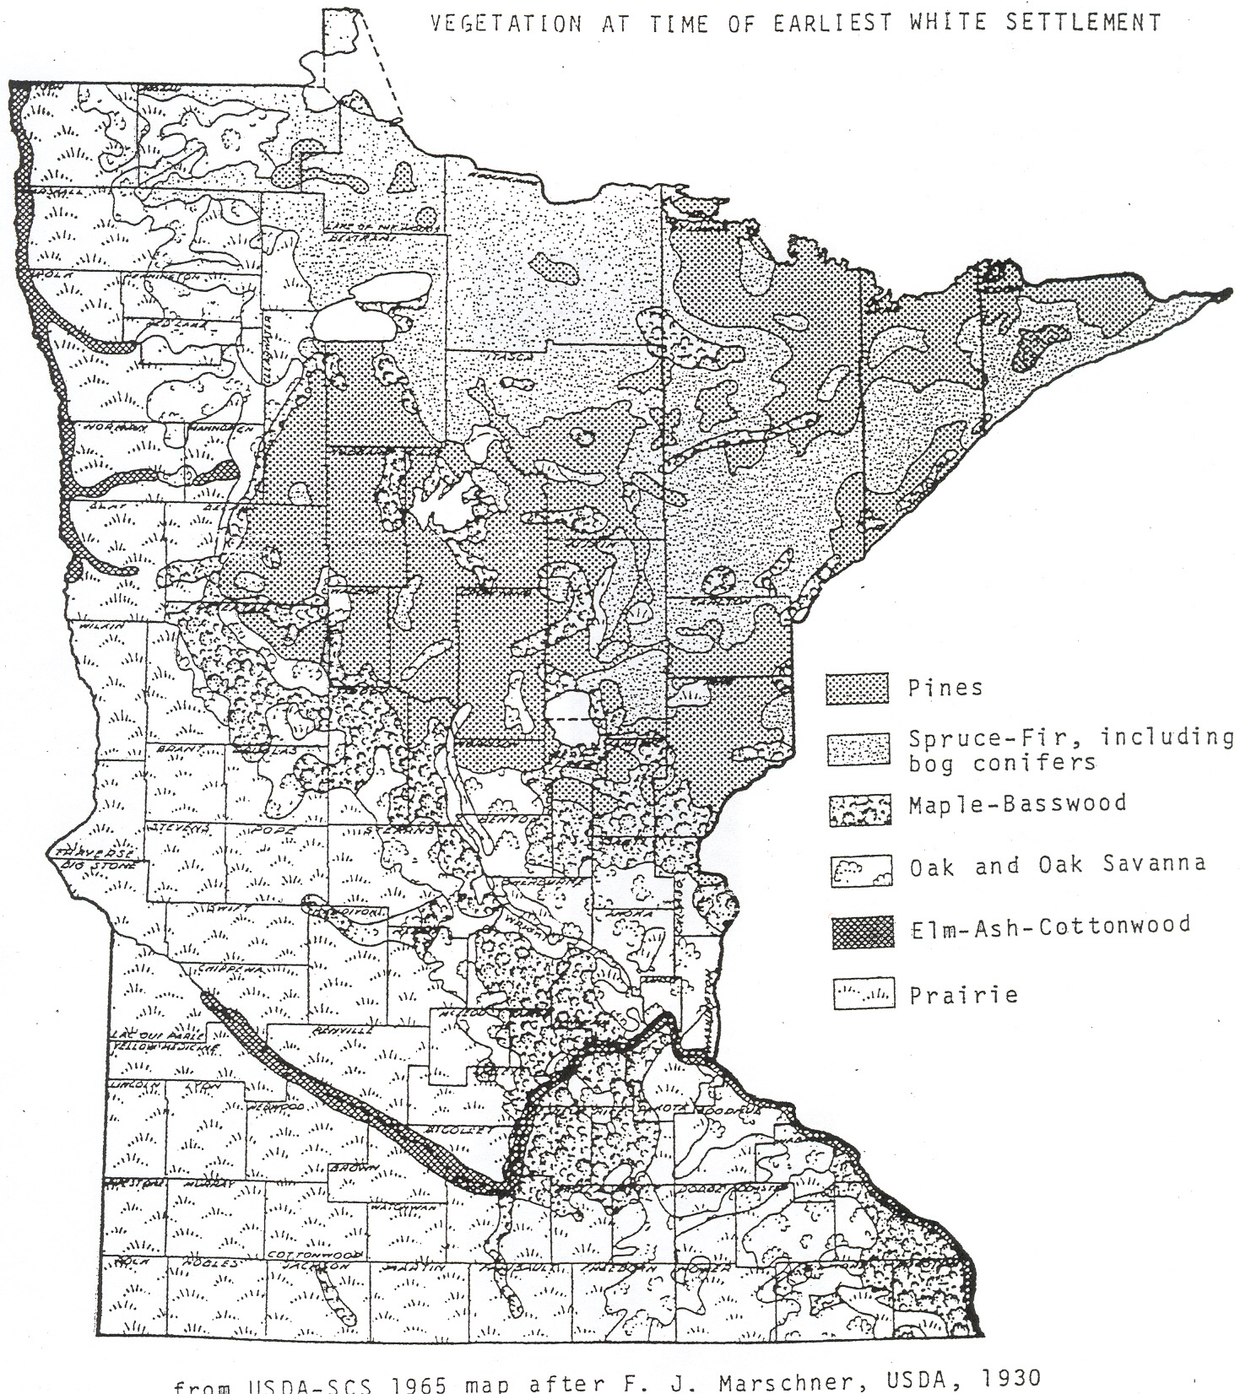

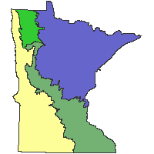
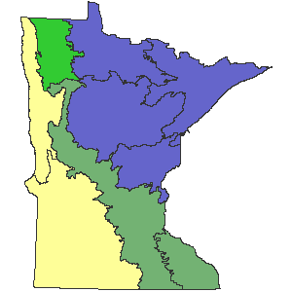
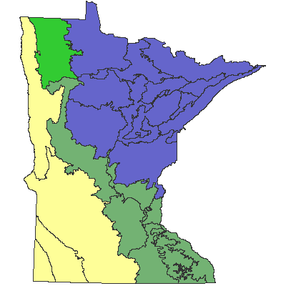

Ecological Classification System

Ecological Land Classification Hierarchy
The Minnesota Department of Natural Resources and the U.S. Forest Service have developed an Ecological Classification System (ECS) for ecological mapping and landscape classification in Minnesota following the National Hierarchical Framework of Ecological Units (ECOMAP 1993). Ecological land classifications are used to identify, describe, and map progressively smaller areas of land with increasingly uniform ecological features. The system uses associations of biotic and environmental factors, including climate, geology, topography, soils, hydrology, and vegetation. ECS mapping enables resource managers to consider ecological patterns for areas as large as North America or as small as a single timber stand and identify areas with similar management opportunities or constraints relative to that scale. There are eight levels of ECS units in the United States. Map units for six of these levels occur in Minnesota: Provinces, Sections, Subsections, Land Type Associations, Land Types, and Land Type Phases. The first three levels are described here.
Provinces are units of land defined using major climate zones, native vegetation, and biomes such as prairies, deciduous forests, or boreal forests. There are 4 Provinces in Minnesota.
Sections are units within Provinces that are defined by origin of glacial deposits, regional elevation, distribution of plants, and regional climate. Minnesota has 10 sections.
Subsections are units within Sections that are defined using glacial deposition processes, surface bedrock formations, local climate, topographic relief, and the distribution of plants, especially trees. Minnesota has 26 subsections.
Land Type Associations are units within Subsections that are defined using glacial landforms, bedrock types, topographic roughness, lake and stream distributions, wetland patterns, depth to ground water table, soil parent material, and pre-European settlement vegetation. Minnesota has 291 land type associations. Though not described here, a GIS cover of land type associations is available on the DNR Data Deli.
Land Types are units within Land Type Associations that are defined using pre-European settlement vegetation, historic disturbance regime, associations of native plant communities (the System level of Native Plant Community Classification), wetland distribution, and soil types. Land Type maps have been made for the Chippewa National Forest.
Land Type Phases are units within Land Types that are defined using a native plant community class, soil type, and topography. Land Type Phase maps exist for portions of the Chippewa National Forest and several State Parks.


