1- French Influence
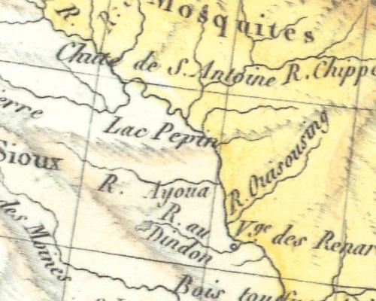

-What are these places known as today…
-Chute de S. Antonie
-Lac Pepin’
-R. Ouisousing

2 – French Influence
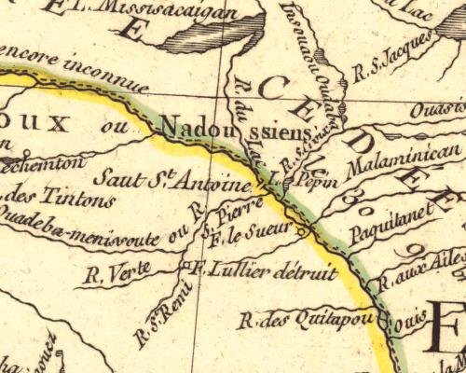

-Where did they draw Lake Pepin?
-What is R. S. Pierre known as today?
-What lake might be L. Mississacaigan?
-What is St Anthony Falls called?
-What might be the modern names for the following rivers:
-Malaminican
-R. des Quitapou
-R. du Lac
3 – French Influence
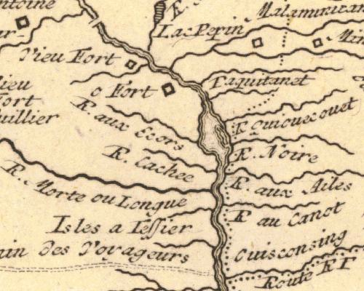

-How many French Forts?
-Where is Lake Pepin on the Map?
-Try to decipher the names of at least four French Rivers.

4 – French Influence
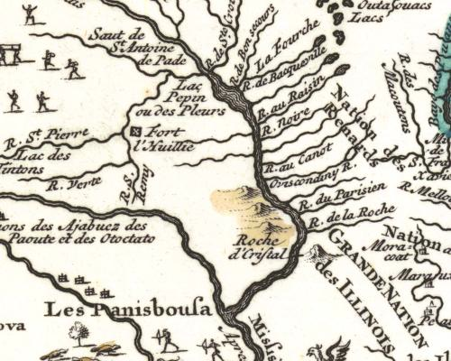

-What economic activity is depicted in the upper left corner?
-What is St Anthony Falls called?
-What is the Minnesota River called?
-The Roche d’ Criftal area probably refers to what?
-What are the two ‘Nations’ referred to on the map?

5 – British Influence
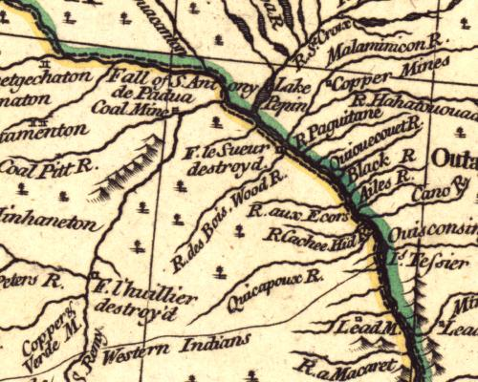
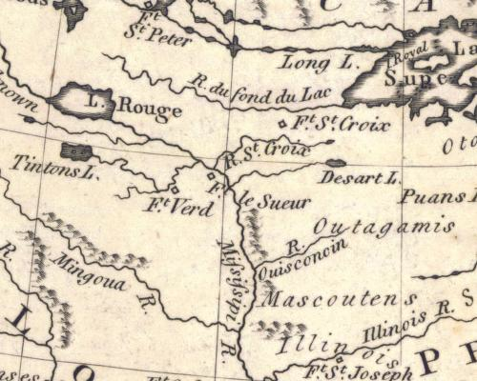

-What two places are marked as destroyed?
-What type of mine is located south of St Anthony Falls?
-What type of mine is located east of Lake Pepin?
-What is the English name for R. des Bois?

6 – British Influence

-What lake/river would you take to reach Fort St Peter?
-How is the Mississippi River spelled?
-What Lake does the Mississippi River start or flow through?
-What river flows into Lake Superior near modern Duluth?
-What 4 forts are on the Map?
-What river might be the Mingoua R. ?

7 – Colonial Influence
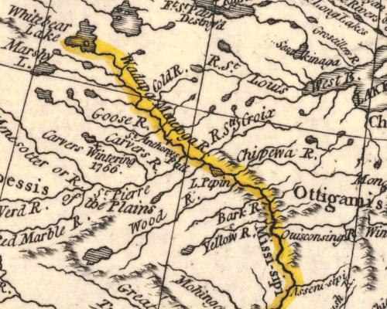

-What two ways is the modern Mississippi River labeled?
-What happened in 1766 along Carvers River?
-What two ways is the modern Minnesota River labeled?
-What is wrong with the orientation/drawing of the St Croix River?

8 – Colonial Influence
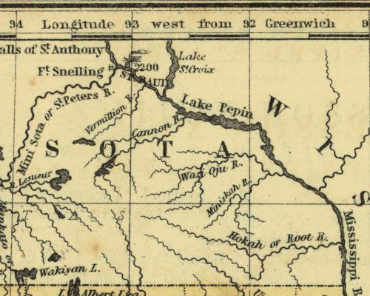

-What are the names of the major streams flowing in SE Minnesota?
-What two names are used for the river SW of Fort Snelling?
-What does the 2200 mean by St Paul?
-What lakes are named on the map?

9 – Colonial Influence
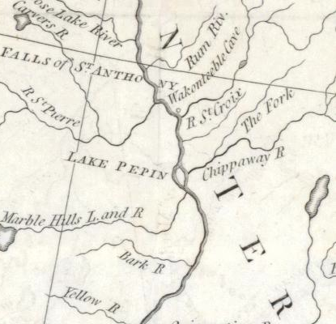

-What lake and river is the Marble Hills Lake and River?
-What cave can be found on this map? Where is it located?
-How is the Chippewa River spelled?
-Which modern river is on the map, but it’s source lake is missing?

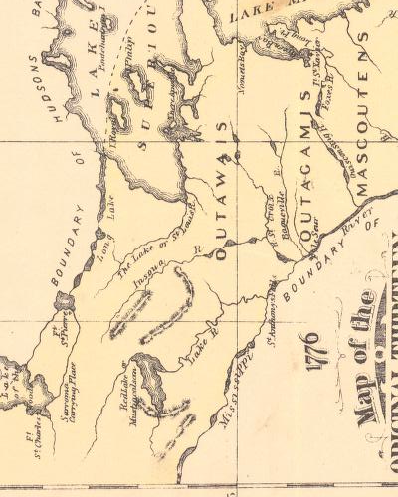
10 – Colonial Influence

-Year of the map?
-Why is there a boundary indicated south of St Anthony Falls?
-What two rivers are a route from Green Bay to the Mississippi River?
-What river drains into the St Croix River?
-What is used for the northern boundary of Minnesota?
-Which way on the map does Red Lake drain? Where does it really go?
11 – Territorial Influence
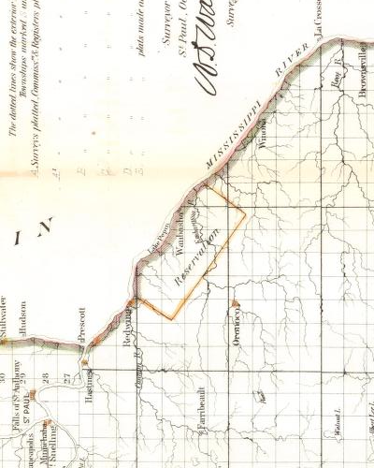

-What are some of the towns already established?
-Are there any remnants in your atlas indicating the Reservation Lands?

12 – Territorial Influence
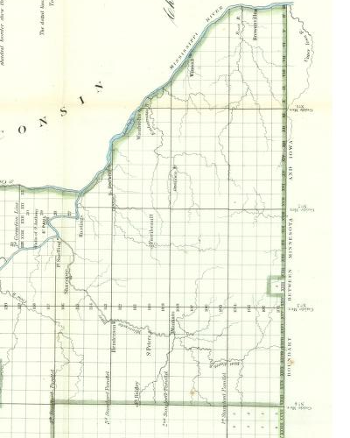

-What is the E-W ‘Line’ north of St. Paul?
-Why was it used?
-Where are there other similar lines on the map?
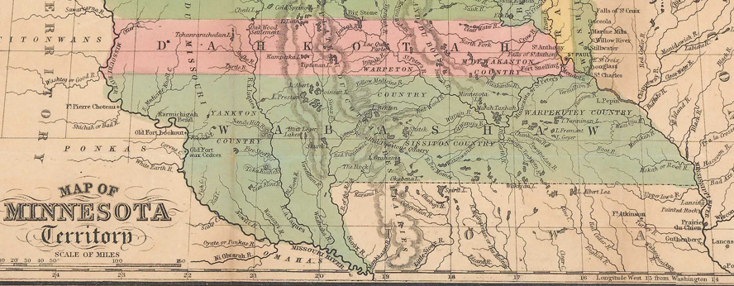

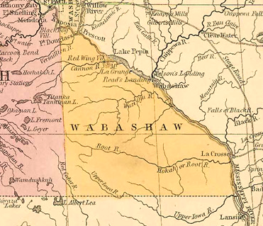
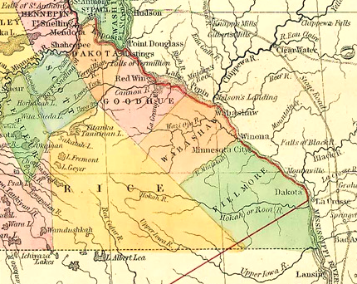

These maps are Territorial proposals for County names and locations.
The top is the oldest and the bottom left to right are getting newer.

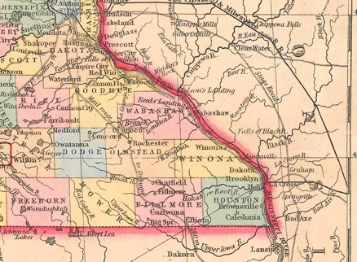

-What changes occurred to Wabasha County?
-Is the last outline of Wabasha County the same as today?
-Why, on the Bottom middle (third) map, do you think they proposed
the orientation of the Counties along the Mississippi River?


