RURAL LANDSCAPE AND SETTLEMENT PATTERNS
________________________________________________________________________________
The purpose of this exercise is to acquaint you with patterns of development for settlements in rural areas. Some towns outgrow their original reason for being established. Use the examples of settlement and location patterns in the handouts to answer the questions.

Put all your answers on back of the page with the world map.
Keep this material for a study guide.
________________________________________________________________________________
LOCATION OF SETTLEMENTS
DEFENSIVE SITES
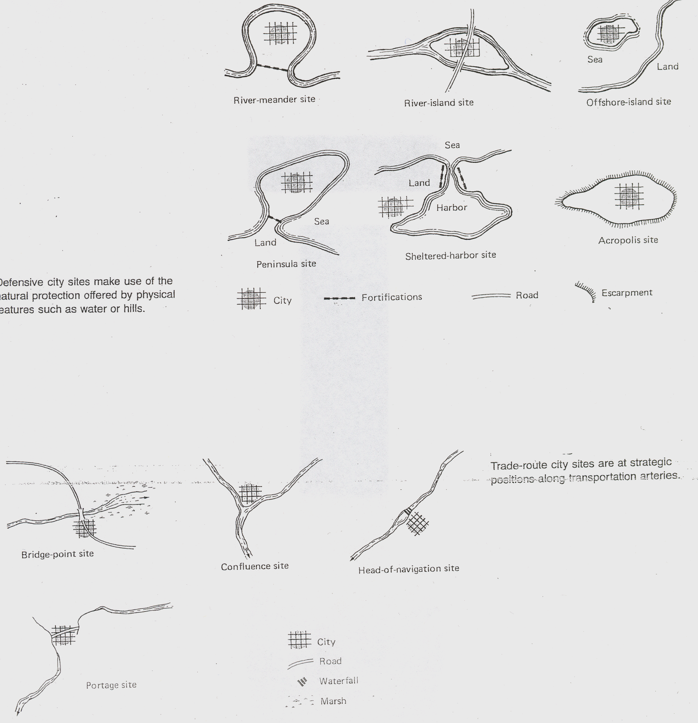

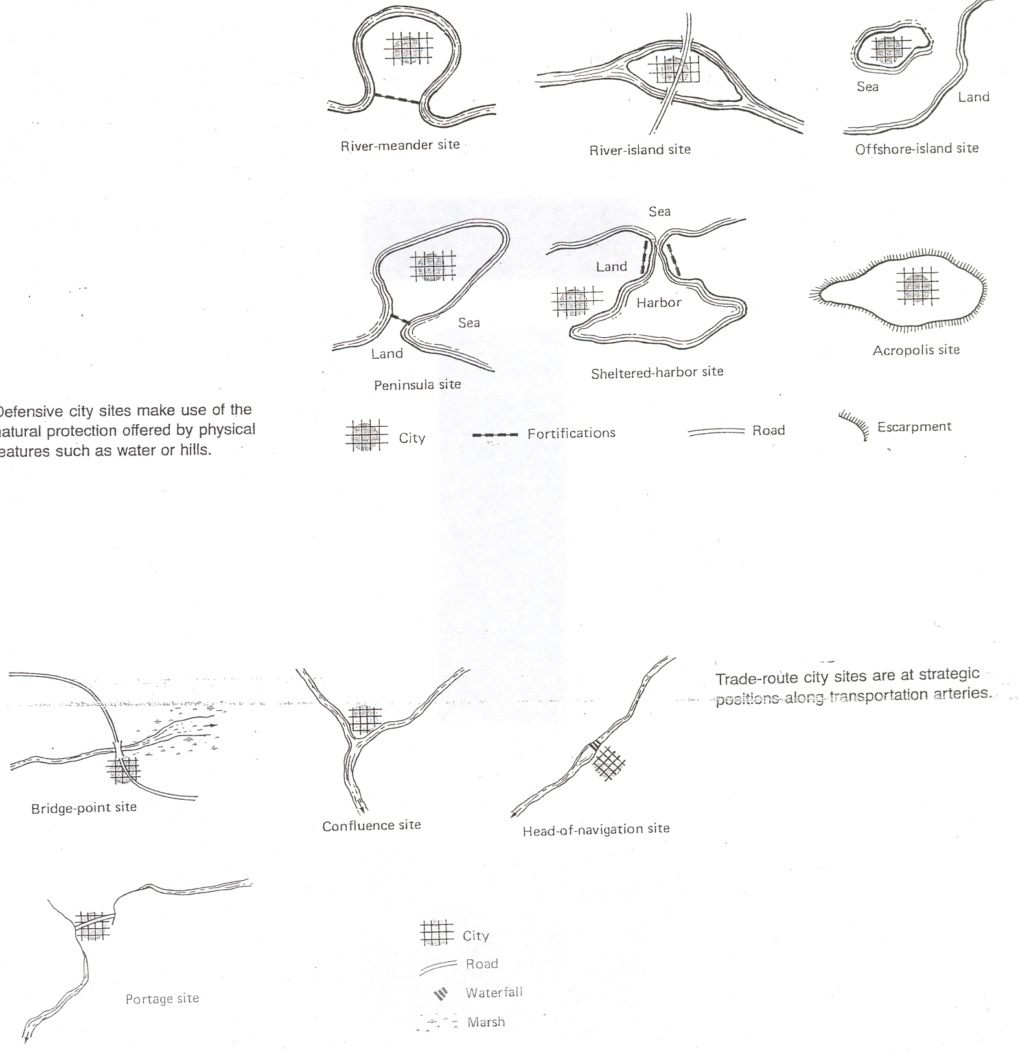

OTHER LOCATION POSSIBILITIES
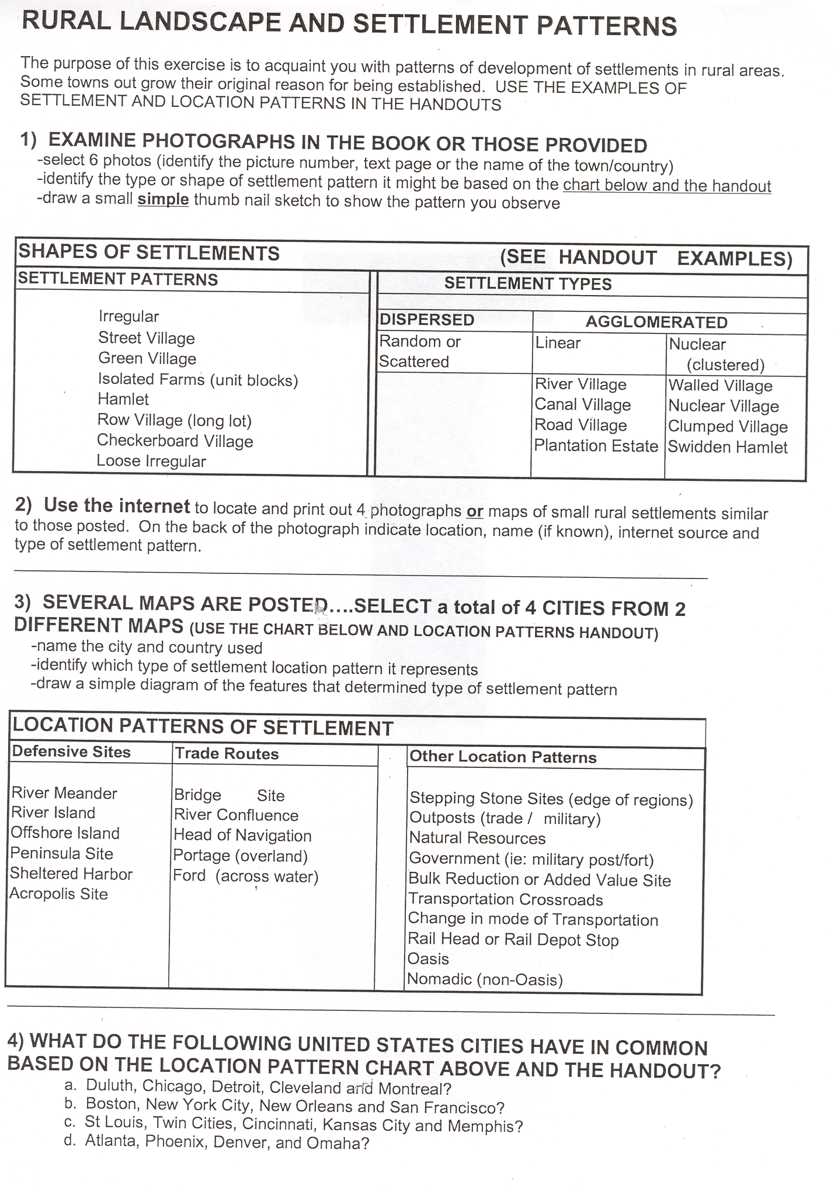

SHAPES OF SETTLEMENTS

Put all your answers on back of the page with the world map.
Keep this material for a study guide.

1) Examine a map of Europe. Locate 5 cities that may have been established as a DEFENSIVE SITE. You can only use an example only once.

___________________________________________________________________________

2) Find 5 air photos in the magazines provided or your text.
-Draw a thumbnail sketch of the street patterns and field patterns
-Label the type of settlement pattern that you identified
-Indicate the date and page number of the magazine or the page number in the text

___________________________________________________________________________

3) Examine the Google air photos provided. Complete the handout that has the world map on top.

____________________________________________________________________________

4) What do the following United States cities have in common? Use all of the possible location types Do not go by today’s activities, but think about what was present when they were first established.
-Duluth, Chicago, Detroit, Cleveland and Montreal
-Boston, New York City, New Orleans and San Francisco
-St Louis, Twin Cities, Cincinnati, Kansas City and Memphis
-Atlanta, Phoenix, Denver and Omaha

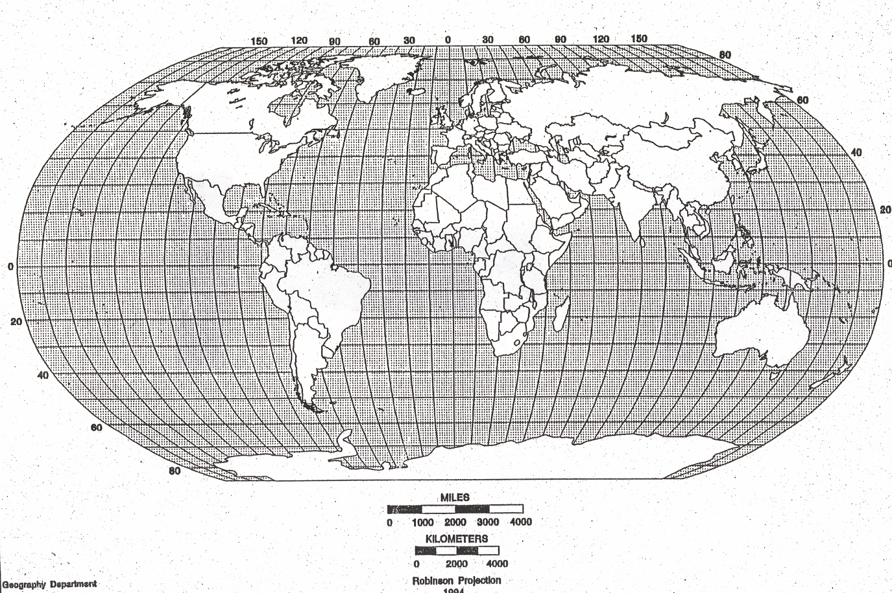

Examine the Google Earth Photos Complete the chart below using Google Earth Photos. Put locations on map above.

LAT /LONG | COUNTRY | TYPE OF PATTERN | COMMENTS



